**DAY 86 DIY SOLUTION**

**Q1. Problem Statement: Clustering, Trend Lines, Reference Lines, and forecasting in tableau.**

1.Load the given datasets into a tableau workbook.

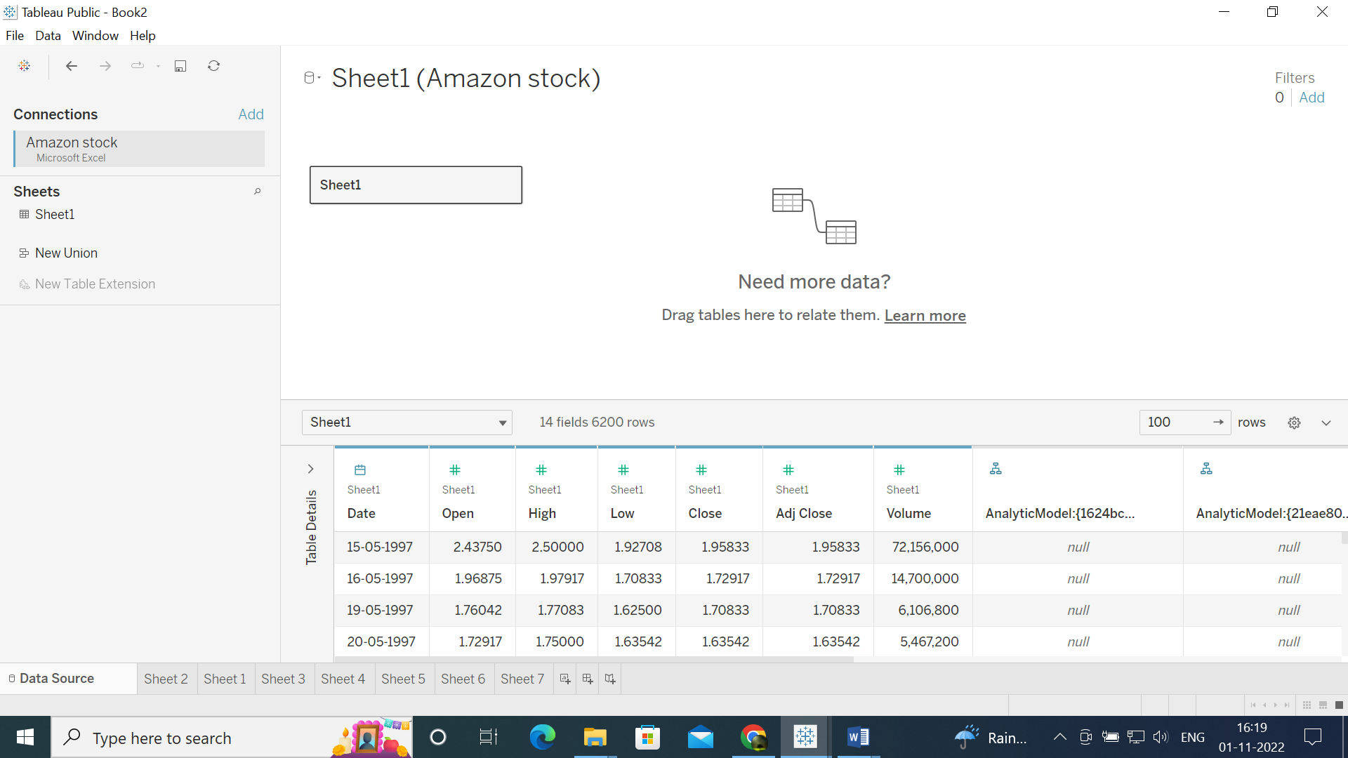

**2.Create a new calculated field as “Difference” based on a single day’s difference between high and low price.**

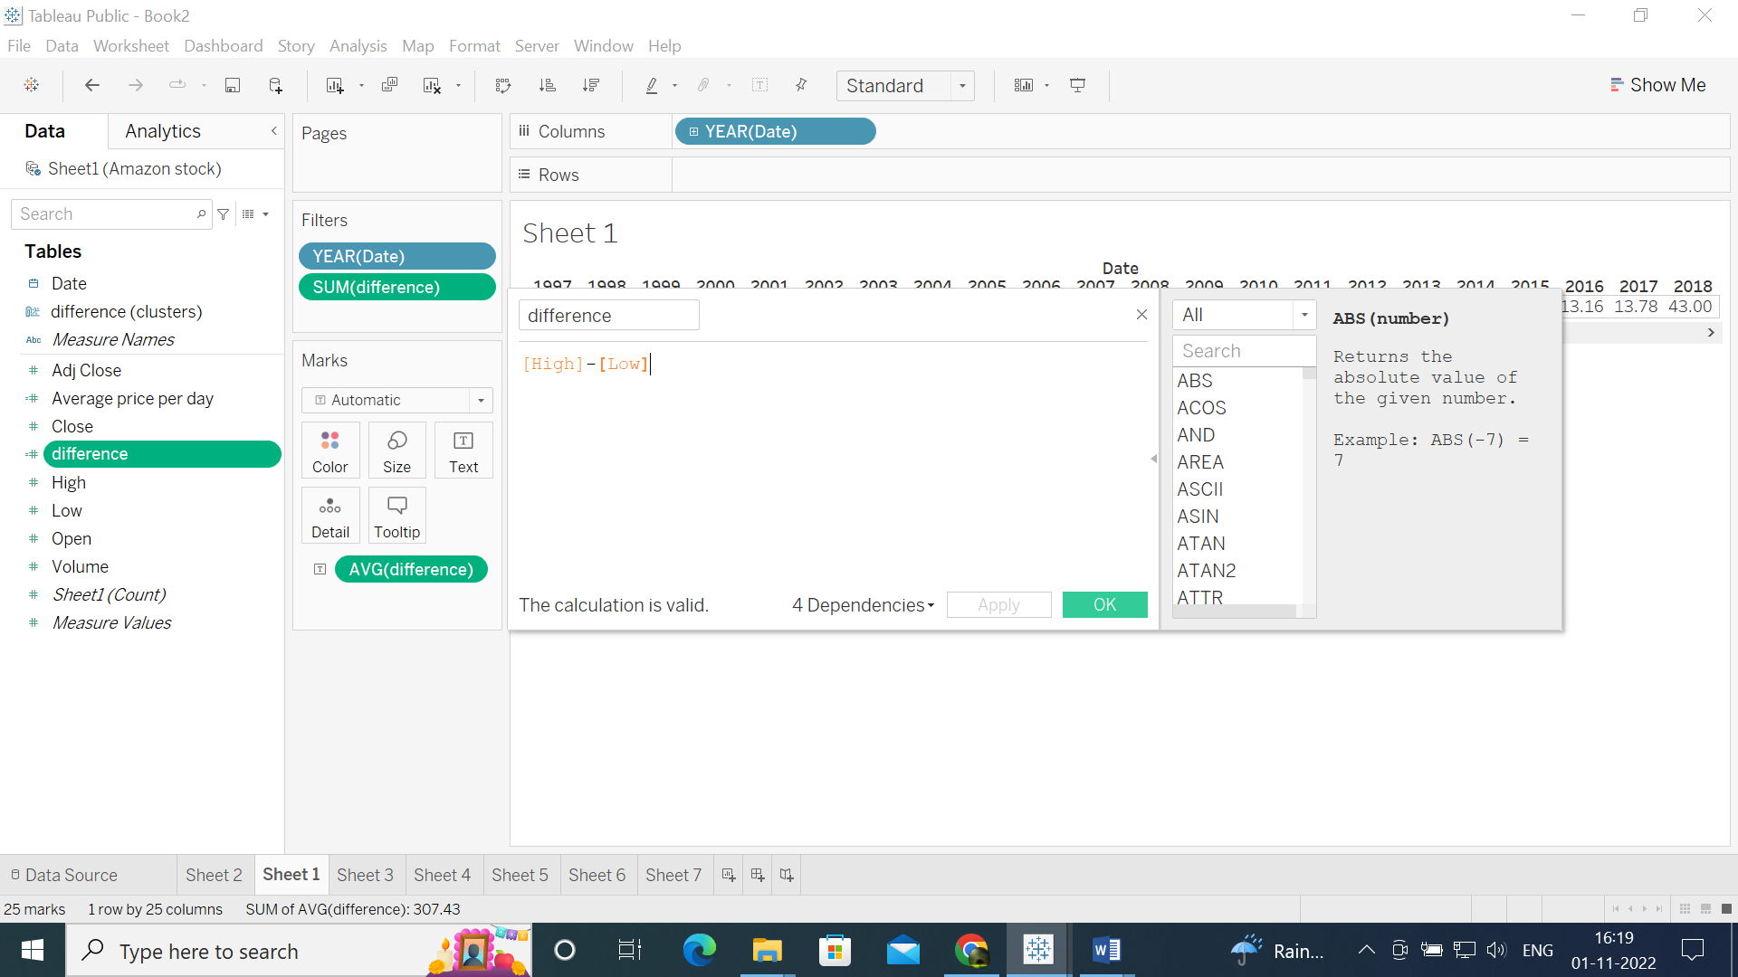

**3.Create a new calculated field as “based on the average of opening and closing value(use this formula in the calculated field: (open+close)/2).**

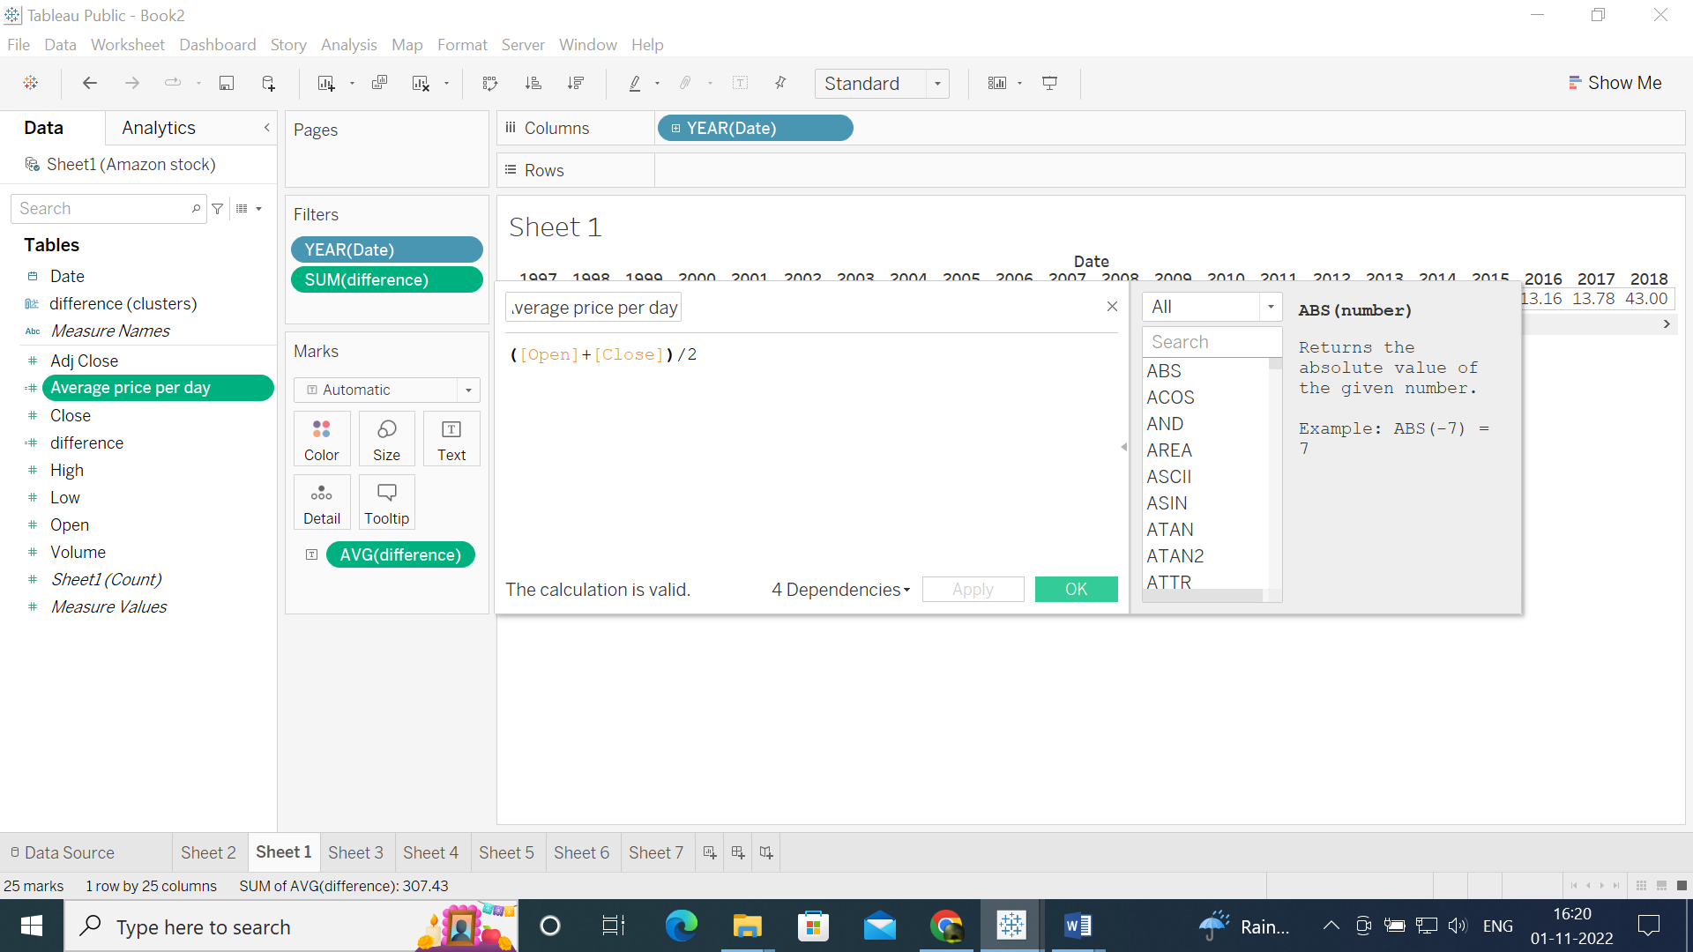

**4.In a new sheet, use a line graph and plot all stock values from start to endpoint year wise with the help of “avg price per day” and use the most fitted trend line and observe the trend .**

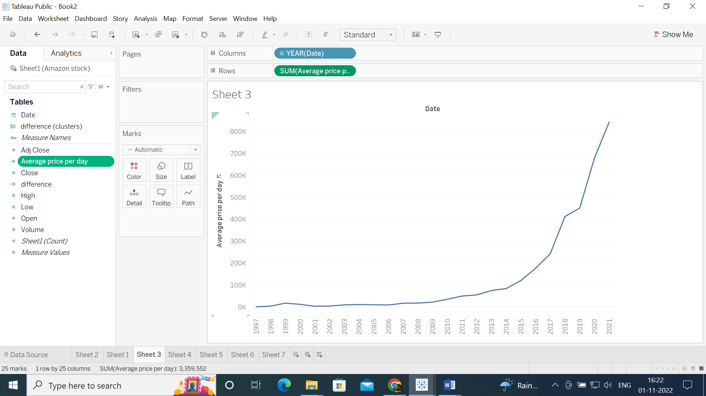

**5.open a new sheet and print the overall average price of the stock and year-wise avg price of the stock with the help of a reference line**

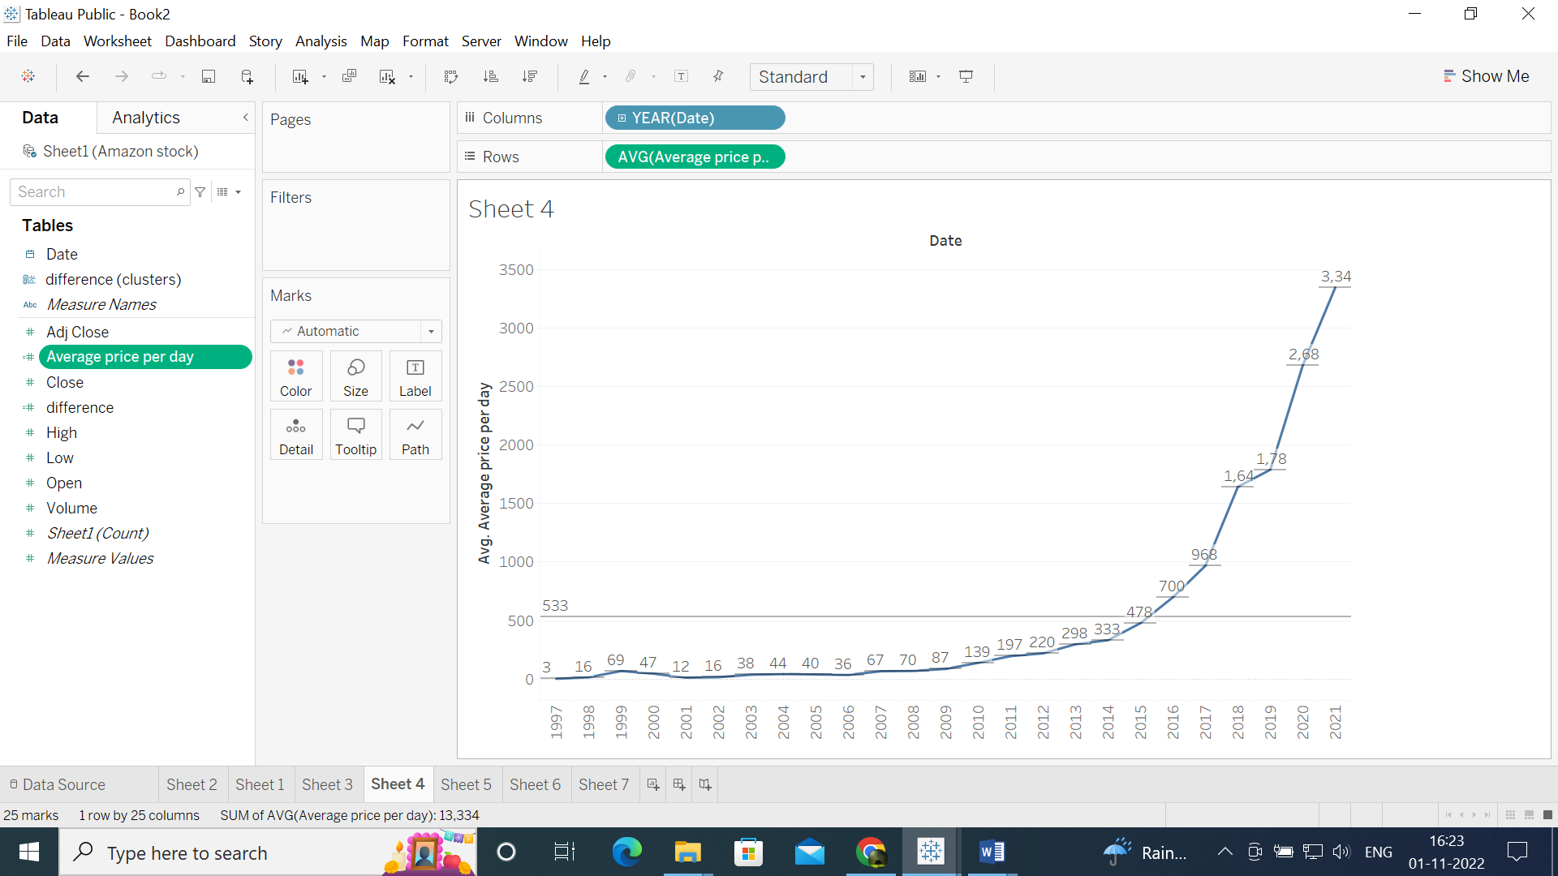

**6.Forecast the avg price of the share for the upcoming five years.**

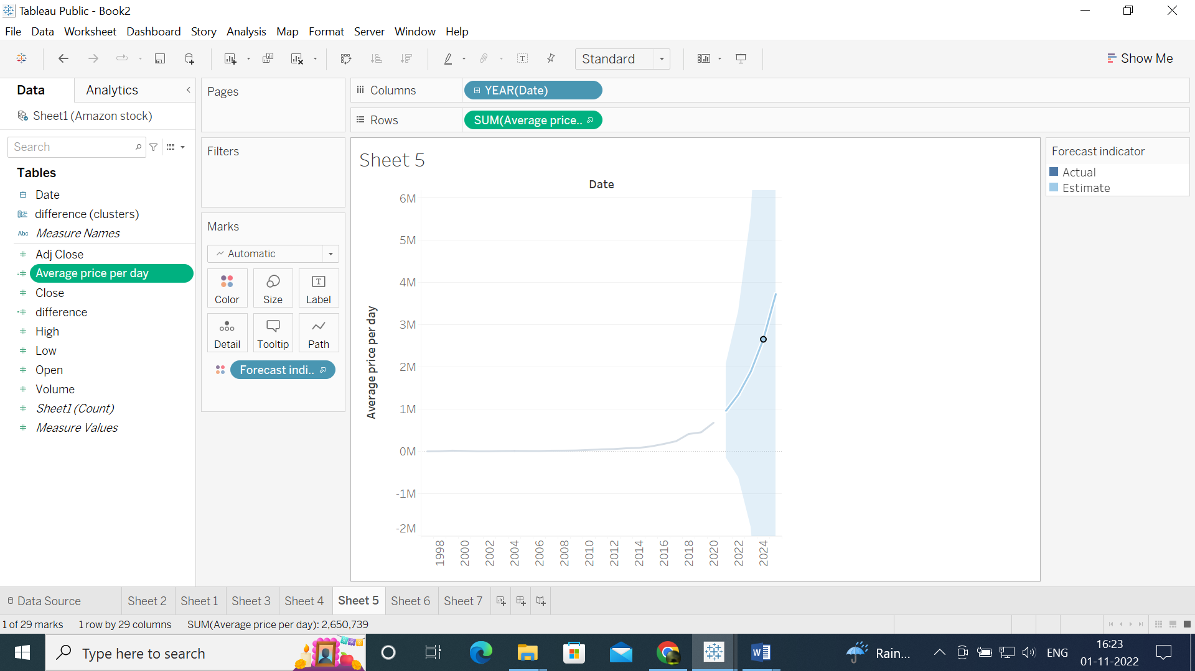

**7.Based on “difference” do clustering and categories data into good, bad, and avg days for amazon stock.**

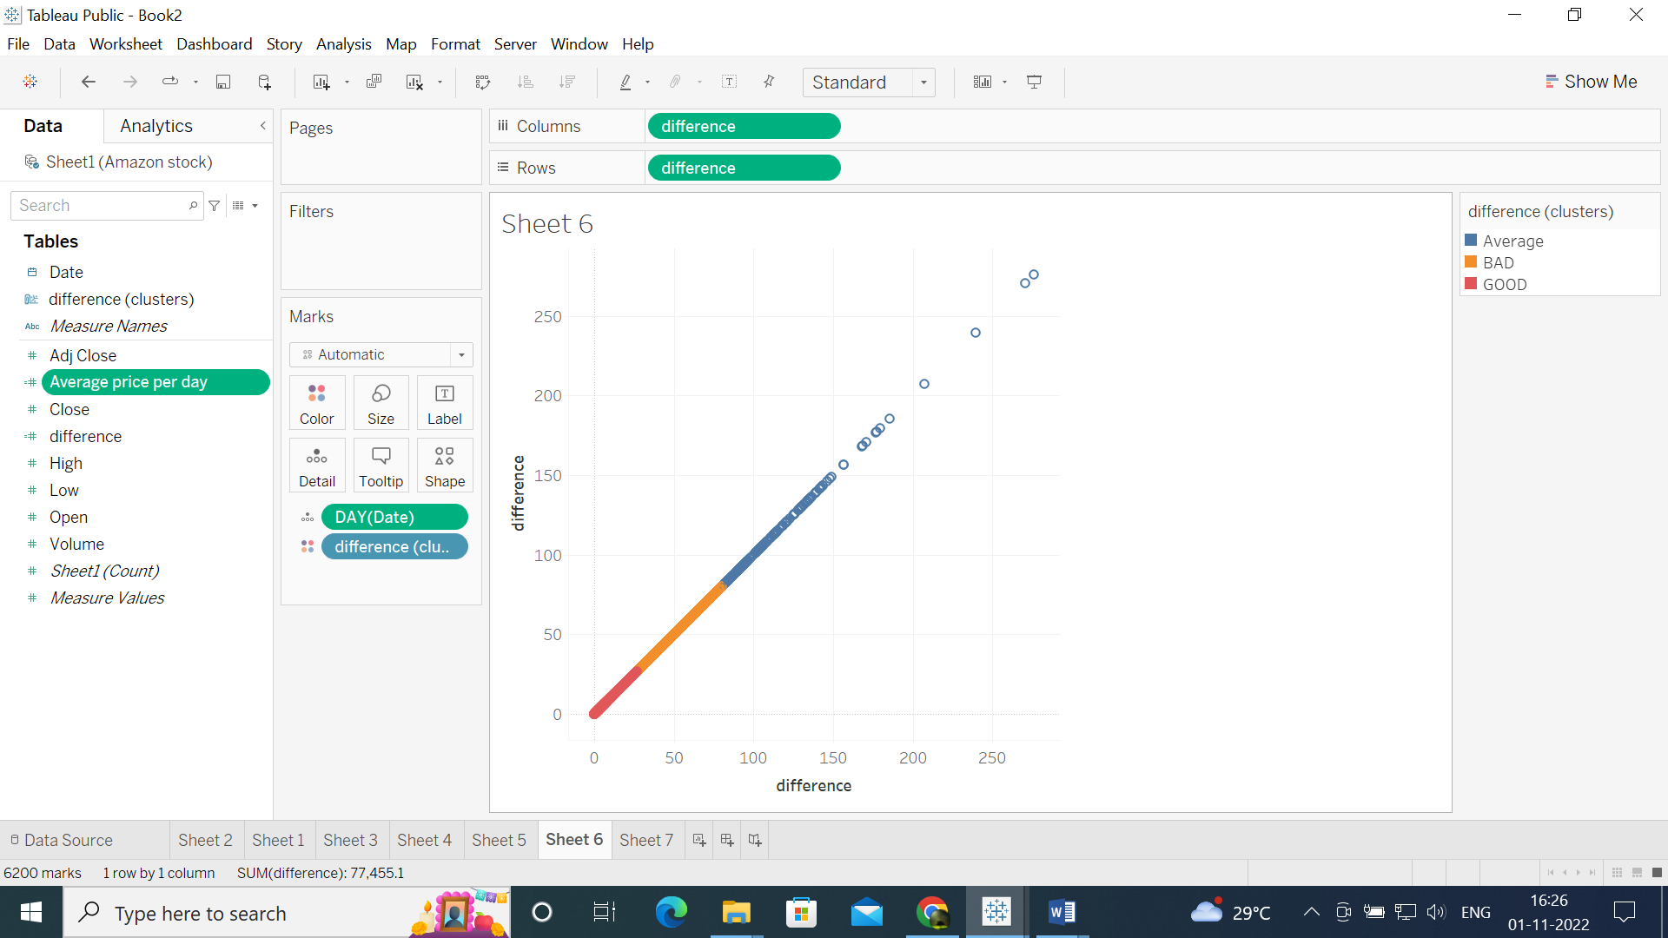

8.Store the above clustering process into the data pane and plot it against year, use an area chart, and observe each category’s occurrence time to determine when amazon had an excellent time stock market.

